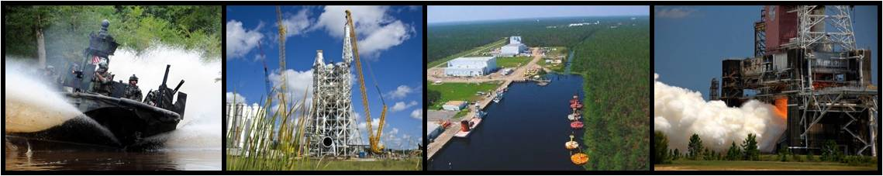
Marine Industries Science & Technology (MIST) Cluster Small Business Summit
Featuring Stennis Large and Medium-sized Companies
September 6, 2016
Millennium Hall, Building 1200, Stennis Space Center, MS 39529

- 9:00am: Tour of Stennis
- 10:00am: Aerojet Rocketdyne, POC: Michael McDaniel, Michael.McDaniel@rocket.com
- 10:30am: Lockheed Martin Space Systems Company, Stennis Propulsion Manufacturing Center, POC Paul Lorio, Paul.A.Lorio@lmco.com
- 11:00am: Rolls Royce N.A., Stennis Outdoor Test Facility; POC: Ian Redfern, Hamish.Guthrie2@rolls-royce.com
- 11:30am: Lunch
- 12:30pm: Alutiiq, POC: Tangela Owens, towens@alutiiq.com
- 1:00pm: General Dynamics Information Technology (GDIT), POC: John Cousins, John.Cousins@gdit.com
- 1:30pm: Geocent, POC: Keith Alphonso, Keith.Alphonso@geocent.com
- 2:00pm: BREAK Sponsored by Kelly Services
- 2:30pm Marstel-Day, POC: Jason See, jsee@marstel-day.com
- 3:00pm: Radiance Technologies, POC: Daniel Anderson, Daniel.Anderson@radiancetech.com
- 3:30pm: Vencore Services and Solutions; PCO: Bill Lingsch, William.Lingsch@vencore.com
Interested in joining MIST? Visit the website www.mistcluster.org.

